**Project Documentation  
(MICHELLE’S SCHOOL FOR GIFTED YOUNGSTER)**

**STUDENT PORTAL WITH ADMIN/STUDENT ROLES AND GRADING FUNCTIONALITY**

**1 INTRODUCTION**

**Official start of our project is today (November 22, 2020)**

**Target to finish our project is December 01, 2020**

**Vision: plan functionality a student portal CRUD (CREATE, READ, UPDATE AND DELETE)**

**Roles:**

**Students:**

* **Accounts made by students.**
* **Students can only view details but not edit or delete them.**
* **Students can delete their own account.**

**Admins:**

* **Can create and delete a student account.**
* **Can update or delete student information.**
* **Can input data of grades and edit/delete them.**
* **Low priority possible functionality**
* **Email confirmation while adding or editing grades for additional layer of security.**
* **Will only add the low priorities if there is extra time.**

**Guest:**

* **Limited functionality can't view sensitive data unless log in**

**1.1 INFORMATION**

**Database: SQL Server-**

**SQL Server is a relational database management system, or RDBMS, developed and marketed by Microsoft.**

**IDE: Visual Studio 2019 (ASP.NET CORE)-**

**ASP.NET Core is a**[**free and open-source**](https://en.wikipedia.org/wiki/Free_and_open-source)[**web framework**](https://en.wikipedia.org/wiki/Web_framework)**and successor to**[**ASP.NET**](https://en.wikipedia.org/wiki/ASP.NET)**, developed by**[**Microsoft**](https://en.wikipedia.org/wiki/Microsoft)**. It is a modular framework that runs on both the full**[**.NET Framework**](https://en.wikipedia.org/wiki/.NET_Framework)**, on**[**Windows**](https://en.wikipedia.org/wiki/Windows)**, and the**[**cross-platform**](https://en.wikipedia.org/wiki/Cross-platform)[**.NET Core**](https://en.wikipedia.org/wiki/.NET_Core)**. However ASP.NET Core version 3 works only on .NET Core dropping support of .NET Framework.**

**Front End: Sass and React Js Framework-**

**Sass is an extension of CSS3, adding nested rules, variables, mixins, selector inheritance, and more. It's translated to well-formatted, standard CSS using the command line tool or a web-framework plugin.**

**React (also known as React.js or ReactJS) is an**[**open-source**](https://en.wikipedia.org/wiki/Open-source)**,**[**front end**](https://en.wikipedia.org/wiki/Front_end_and_back_end)**,**[**JavaScript library**](https://en.wikipedia.org/wiki/JavaScript_library)[**[3]**](https://en.wikipedia.org/wiki/React_(web_framework)#cite_note-react-3)**for building**[**user interfaces**](https://en.wikipedia.org/wiki/User_interfaces)**or UI components.**

**Architecture: Onion-**

**Onion architecture layers interact to each other by using the Interfaces.**

**Data Access: Entity Framework-**

**Prior to .NET 3.5, we (developers) often used to write ADO.NET code or Enterprise Data Access Block to save or retrieve application data from the underlying database.**

**1.2 WORKFLOW**

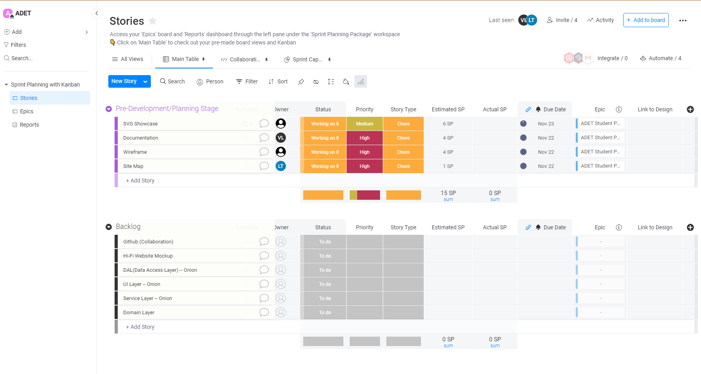

**We’re using agile methodology, scrum framework and sprint planning**

**Agile methodology-** **Agile is a process by which a team can manage a project by breaking it up into several stages and involving constant collaboration with stakeholders and continuous improvement and iteration at every stage. The Agile methodology begins with clients describing how the end product will be used and what problem it will solve.**

**Scrum framework- Scrum is a framework within which people can address complex adaptive problems, while productively and creatively delivering products of the highest possible value.**

**Sprint planning- Sprint Planning is time-boxed to a maximum of eight hours for a one-month Sprint. For shorter Sprints, the event is usually shorter. The**[**Scrum Master**](https://www.scrum.org/resources/what-is-a-scrum-master)**ensures that the event takes place and that attendants understand its purpose. The Scrum Master teaches the Scrum Team to keep it within the time-box.**

**We decided to use all of these to be flexible in our development process.**

**We’re planning four hours to do this project each days.**

**TEAM ROLES**

**Kyla Samson: UI/UX**

**Michelle Espeleta: Visual Design**

**Larz Timothy Pal-ing: Frontend and Framework (ReactJs)**

**Vince Lawrence Repia: Documentation and SDLC implementation (Scrum Master)**

**Everyone: Backend (Asp.Net Core and Onion Architecture)**

**TEAM PROGRESS**

**WIREFRAME**

**(in progress wireframe)**

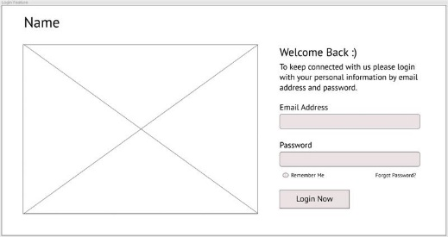

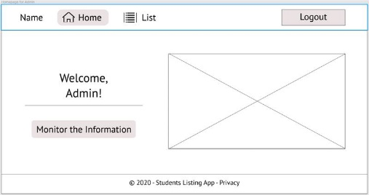 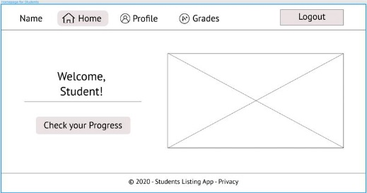

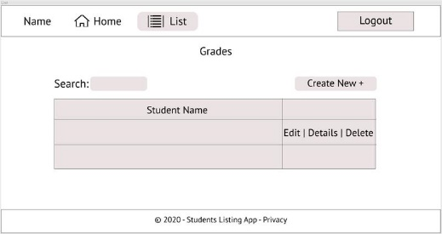 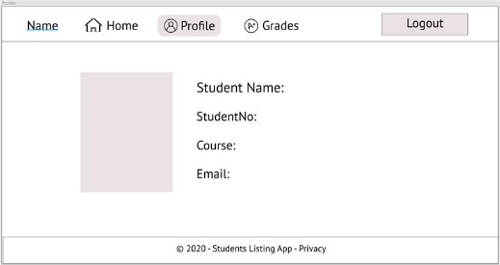

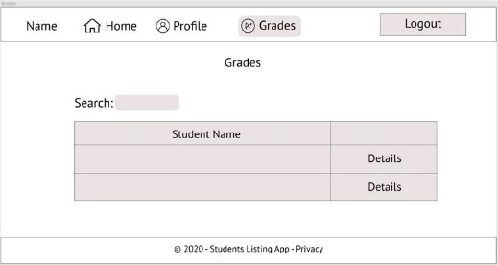

**INITIAL DRAFTS OF SVG SHOWCASE**

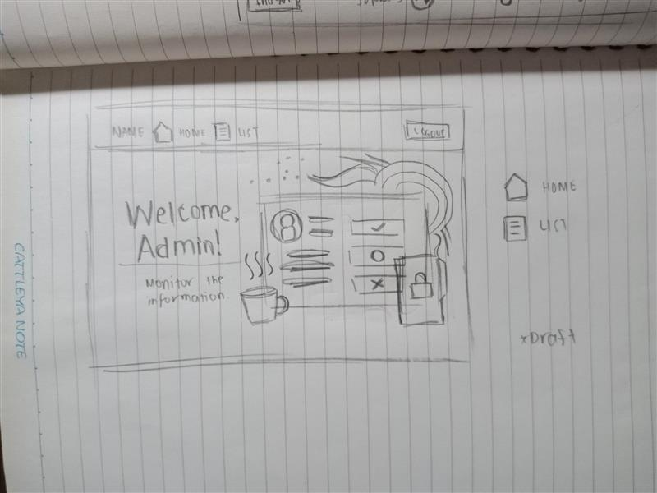 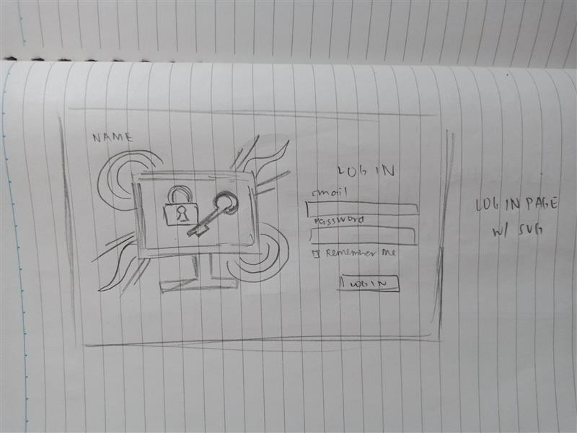

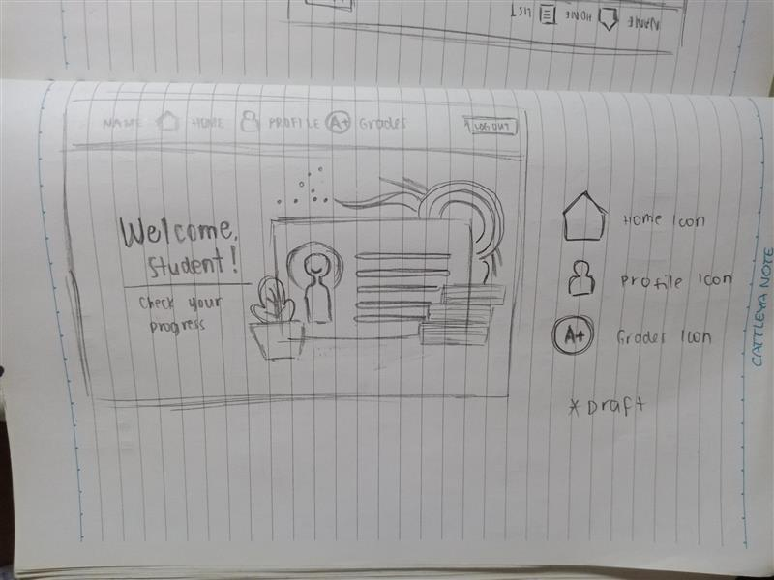

**SITE MAP**

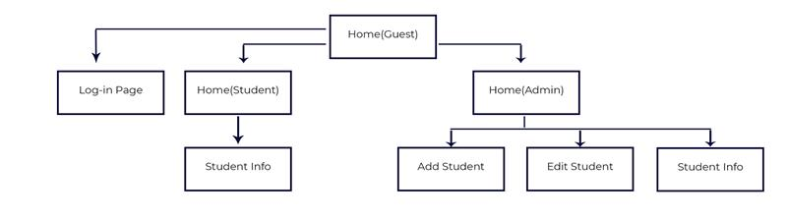



**SVG Showcase**



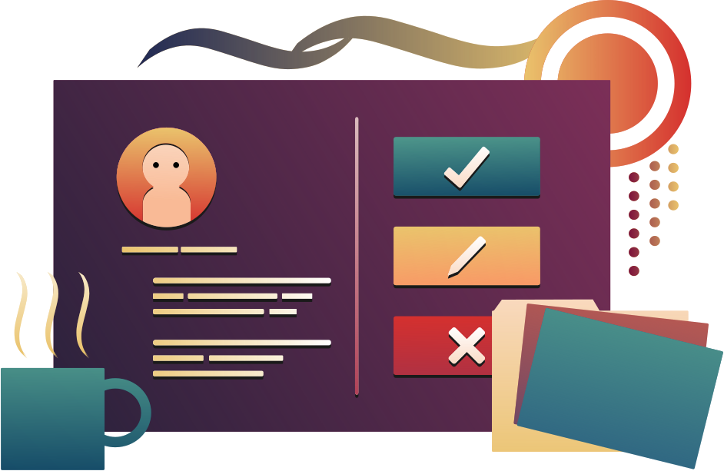

**SVG Icons**

**(**

** **

** **



**Log in Page (Dark & Light Mode)**

**(entry page to a website)**

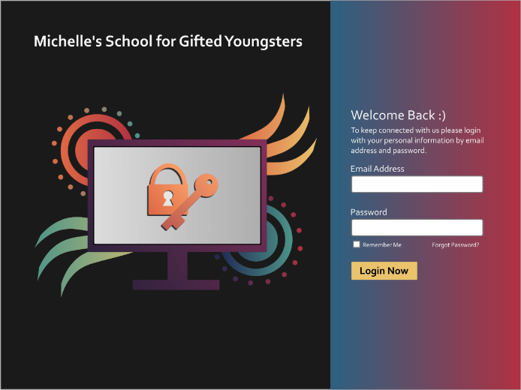 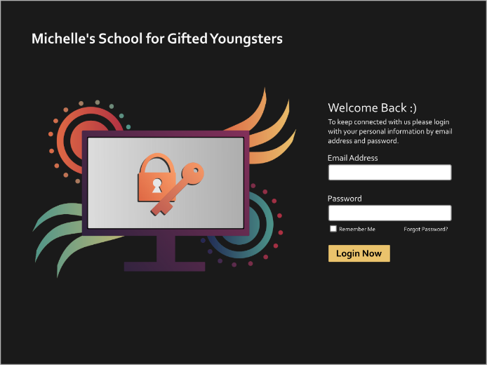

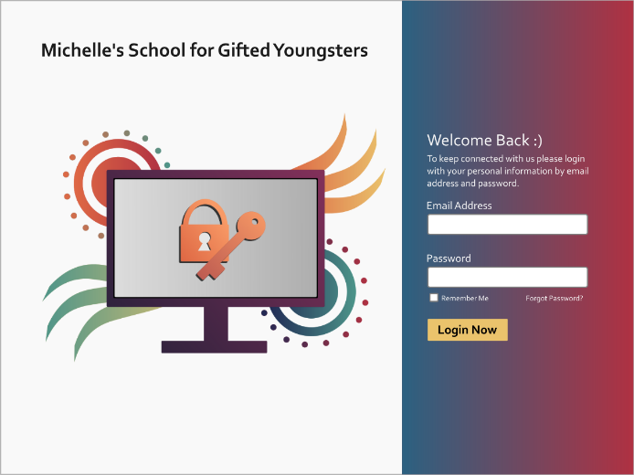 

**Forgot Password Page (Dark & Light Mode)**

**(when you request to reset the password on the website**)

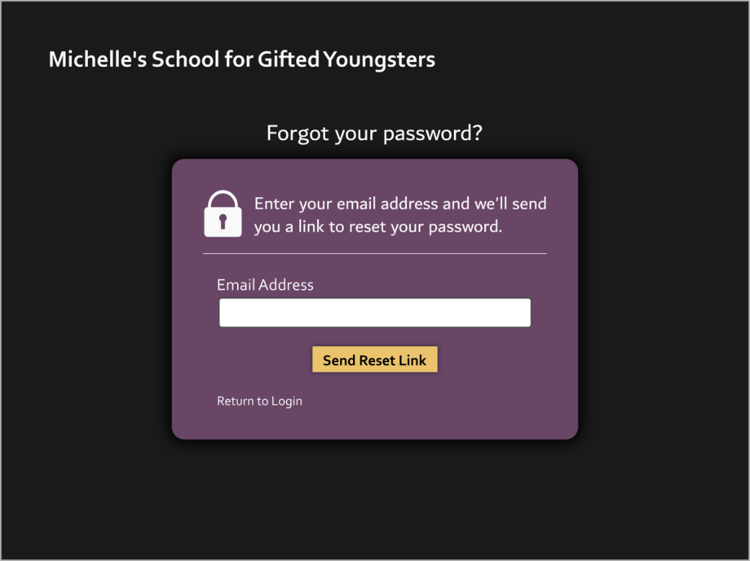

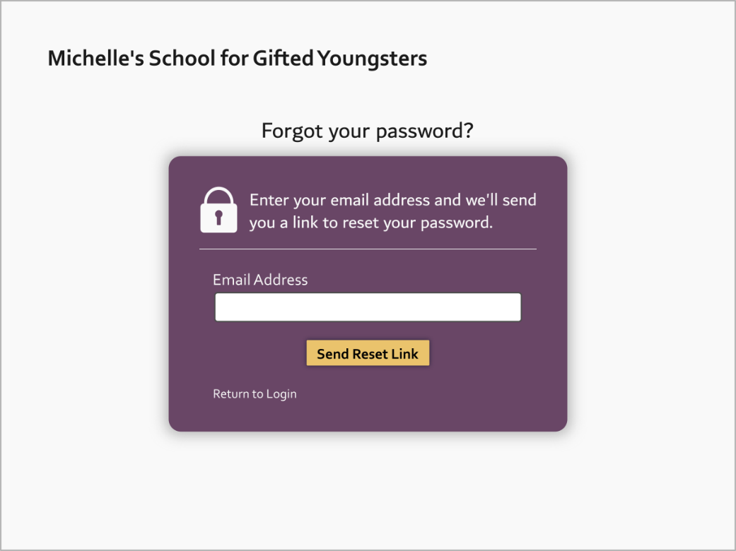

**Reset Password Page (Dark & Light Mode)**

**(the action of invalidating the current password for an account**)

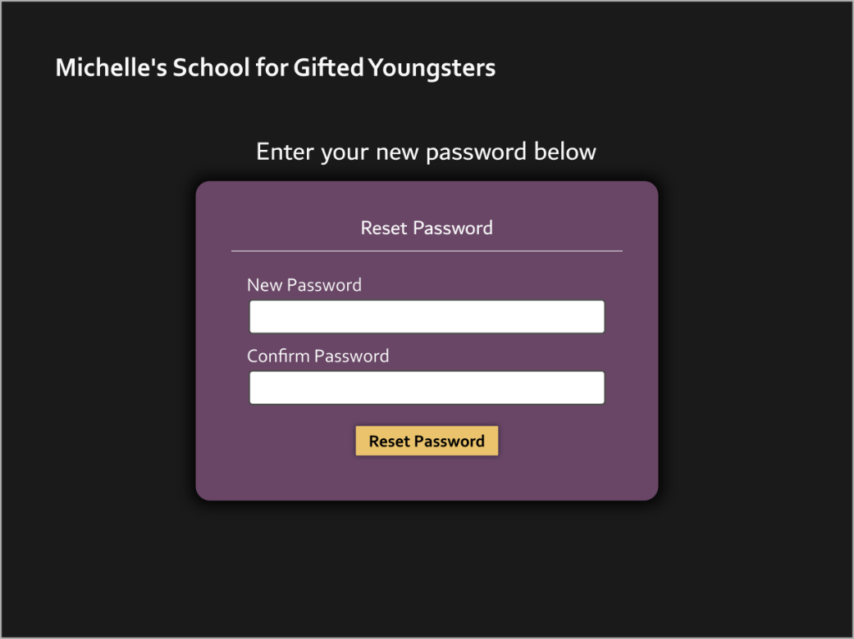

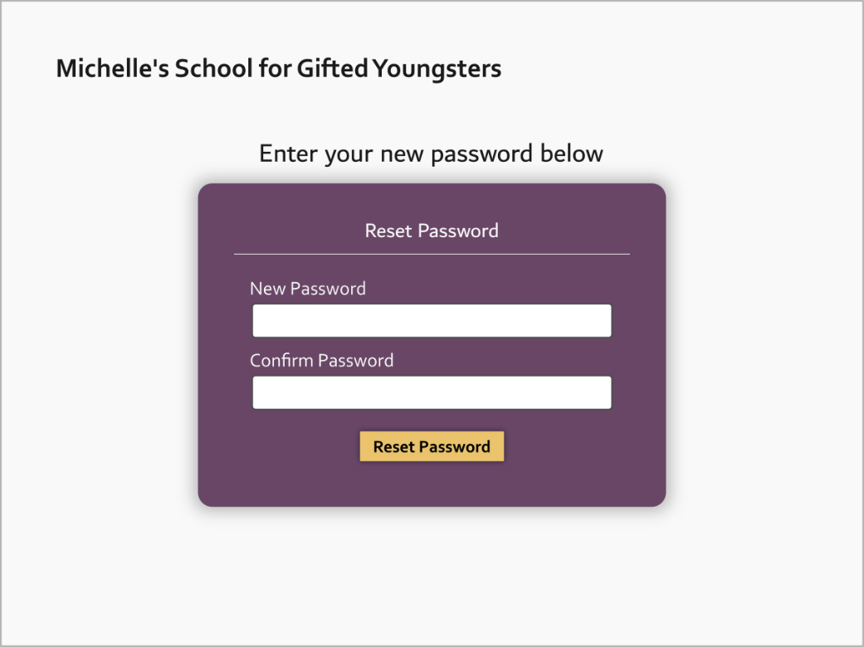

**Admin Homepage (Dark & Light Mode)**

**(can update and delete the grades of a student)**

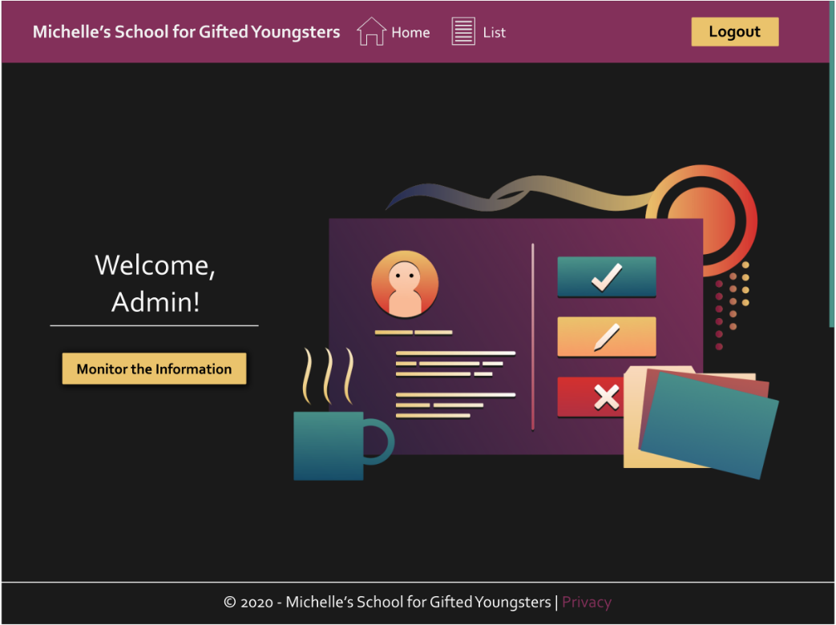

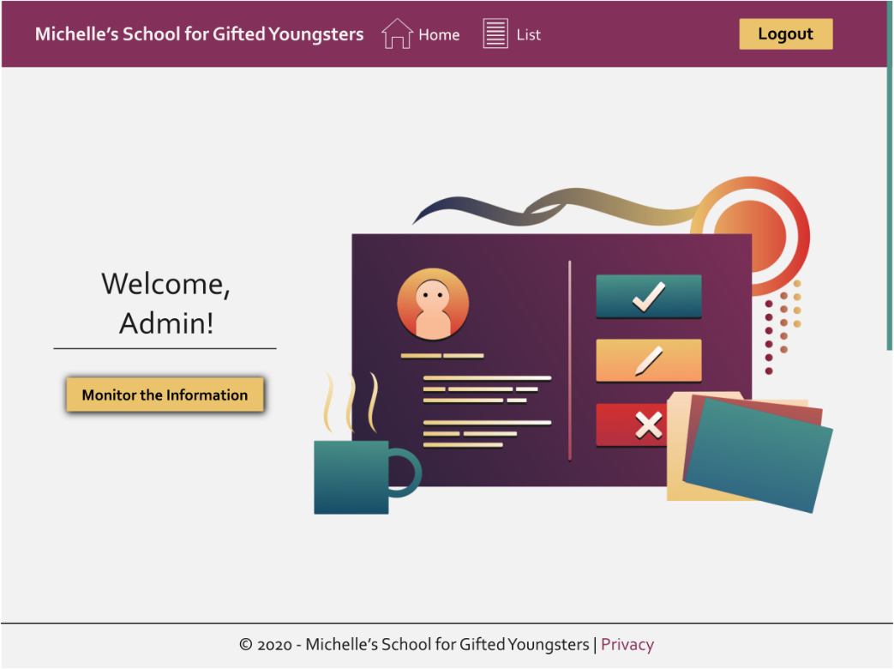

**Student Homepage (Dark & Light Mode)**

**(gain access to an education organization's programs and other learning related materials**)

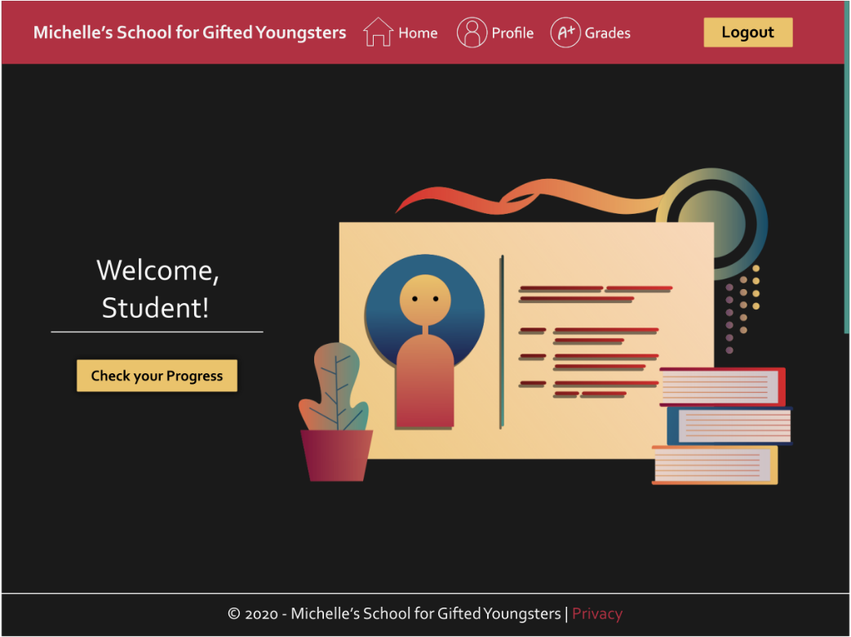

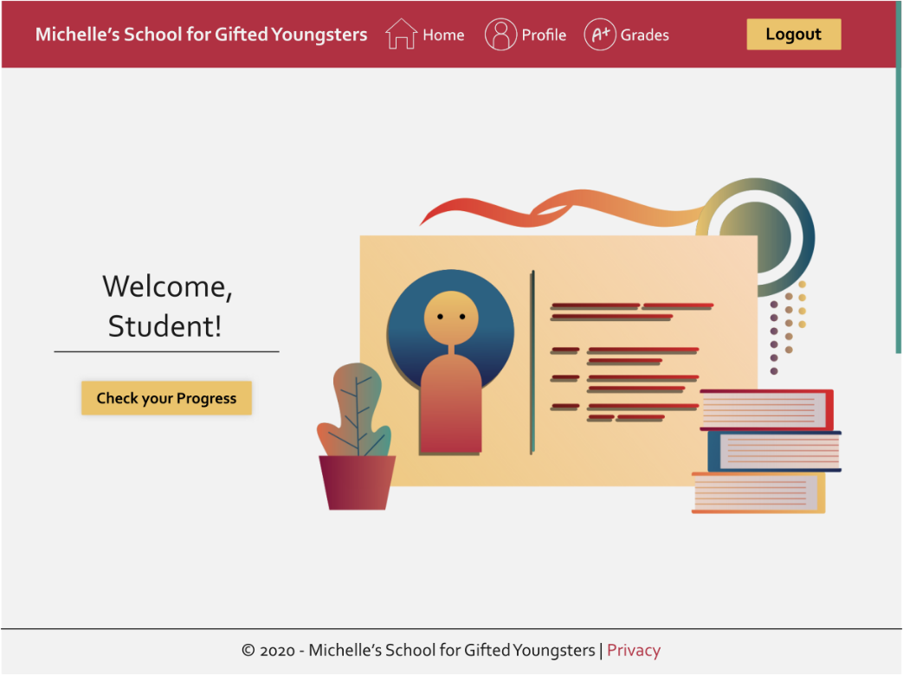

**Complete Wireframe**

**(an image or set of images which displays the functional elements of a website or page, typically used for planning a site's structure and functionality**)

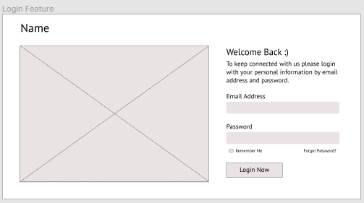

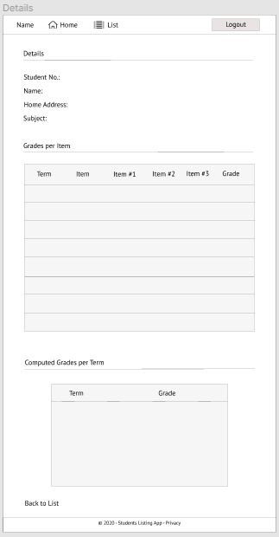

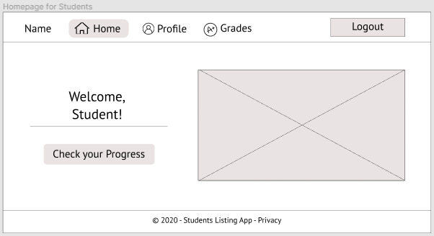

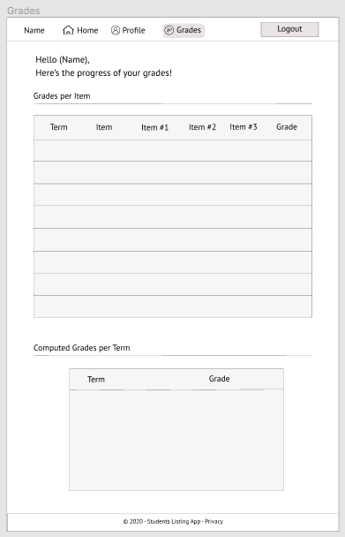

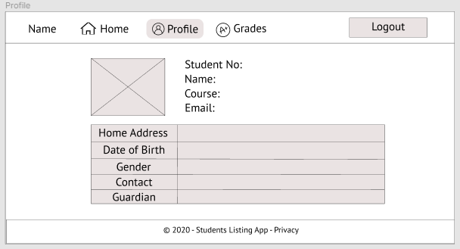

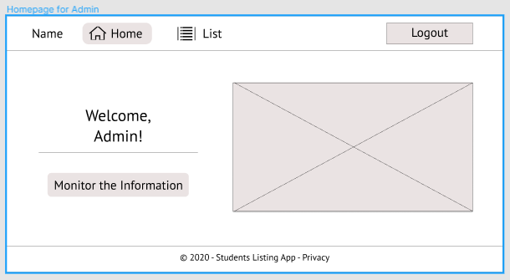

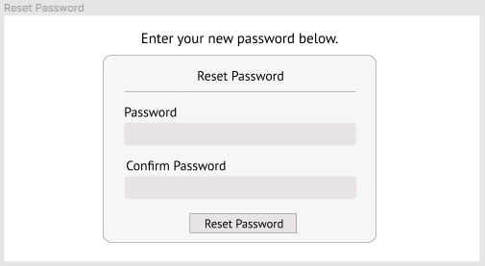

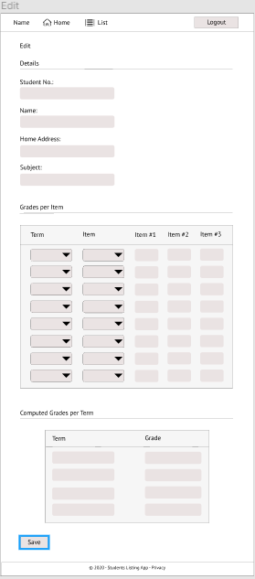

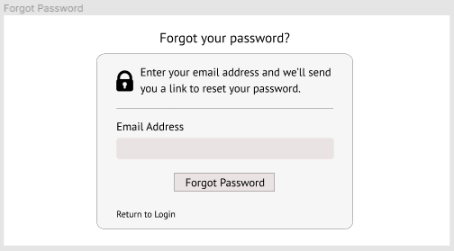

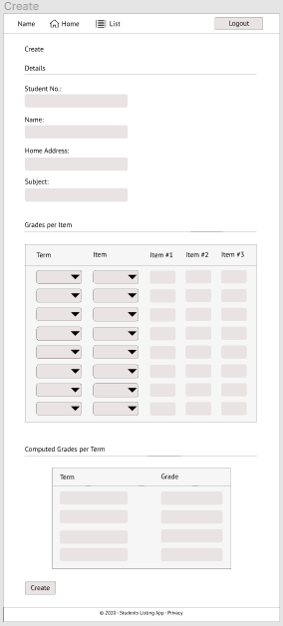

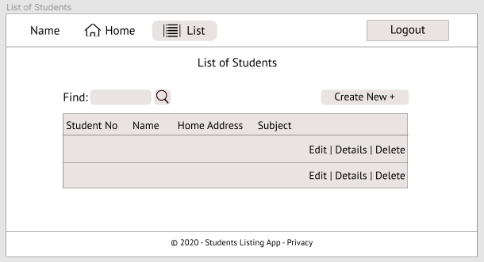

**Student Profile Page (Dark & Light Mode)**

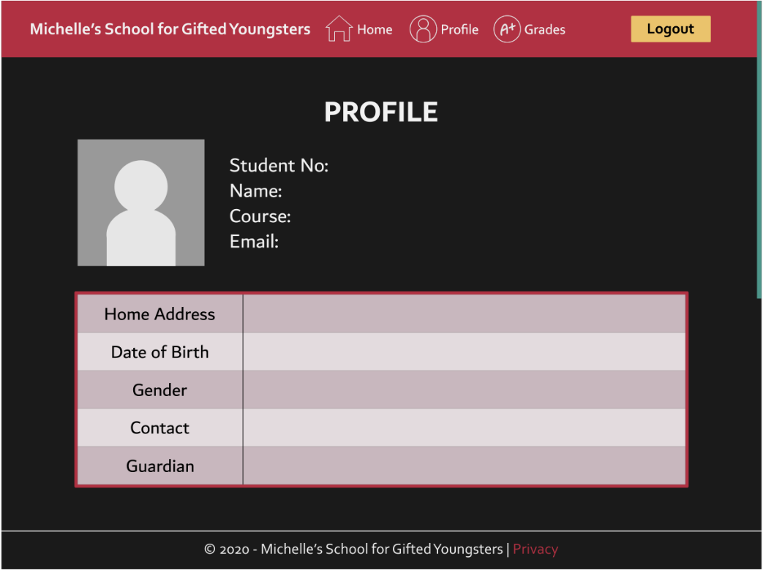

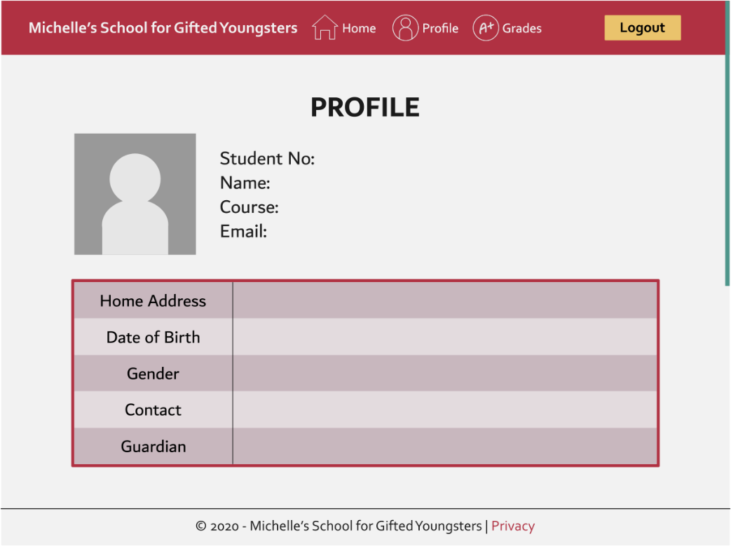

**Student Grades Page (Dark & Light Mode)**

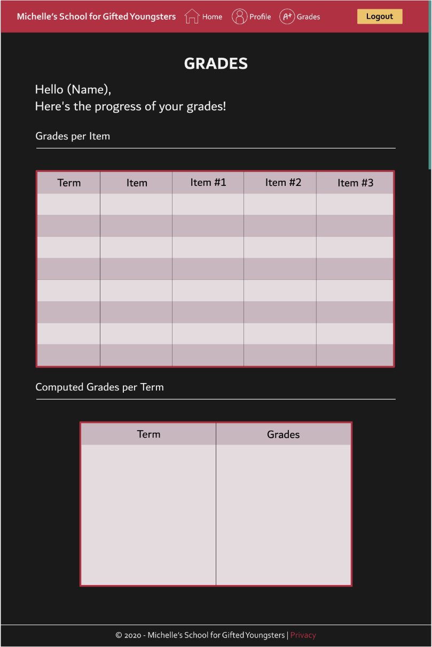

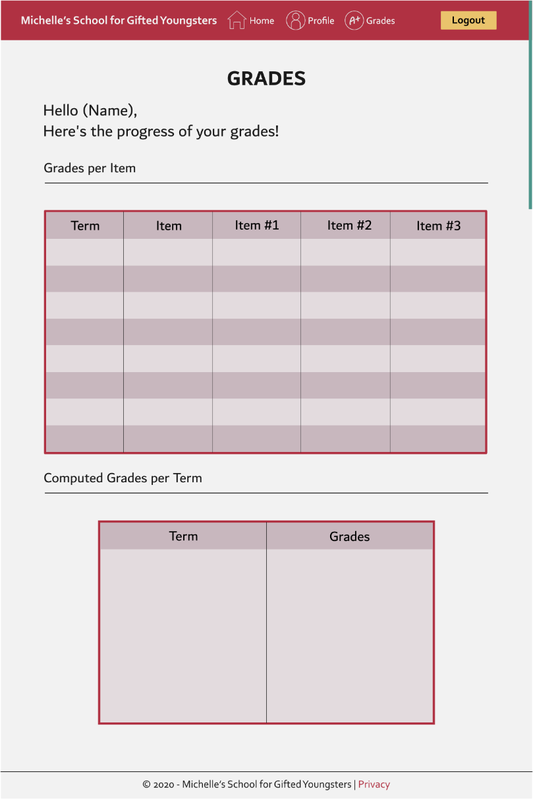

**Admin List Page (Dark & Light Mode)**

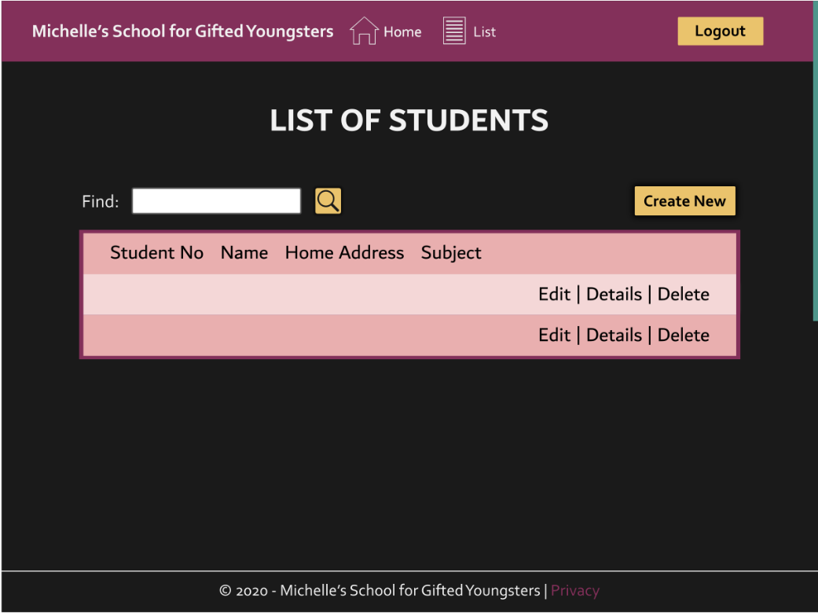

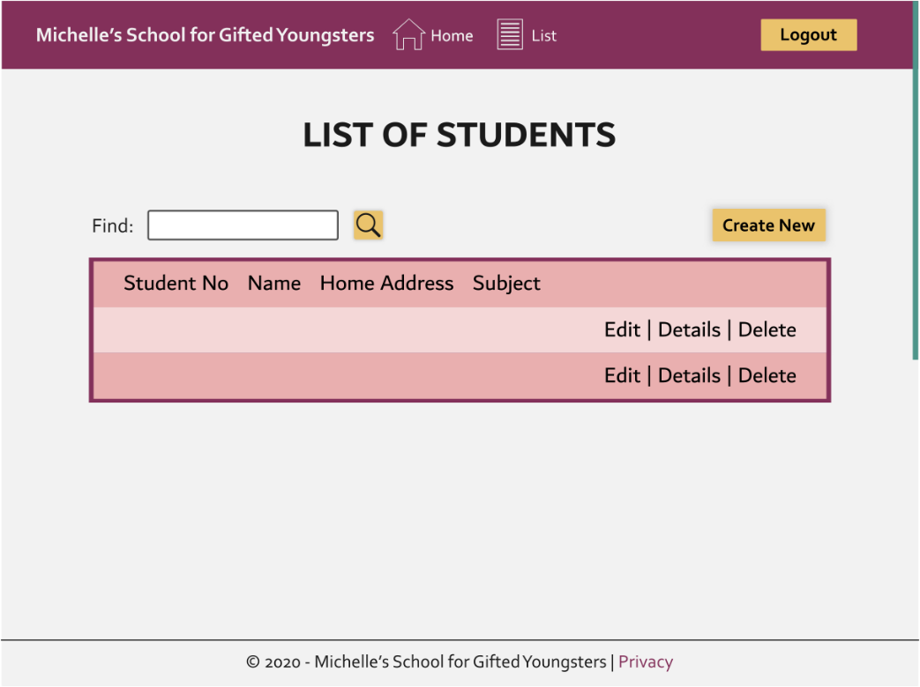

**Admin Create Page (Dark & Light Mode)**

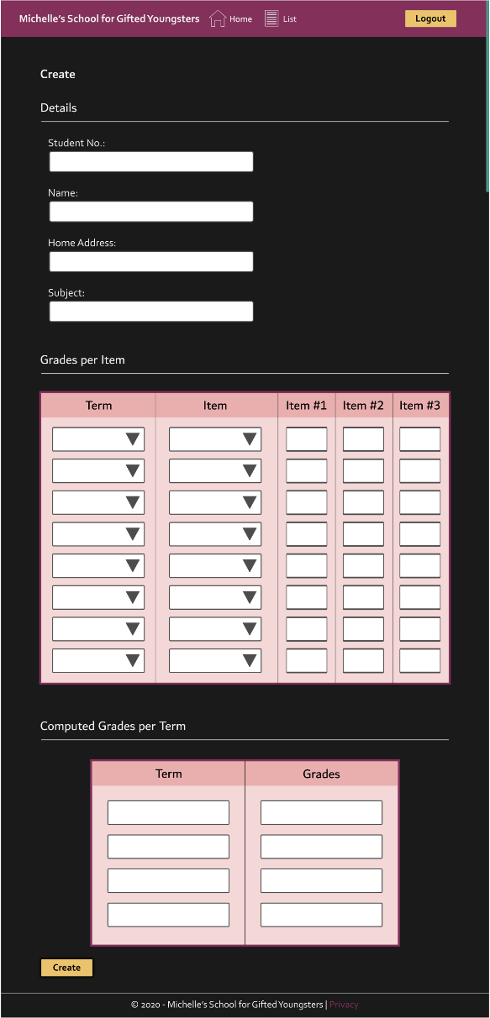

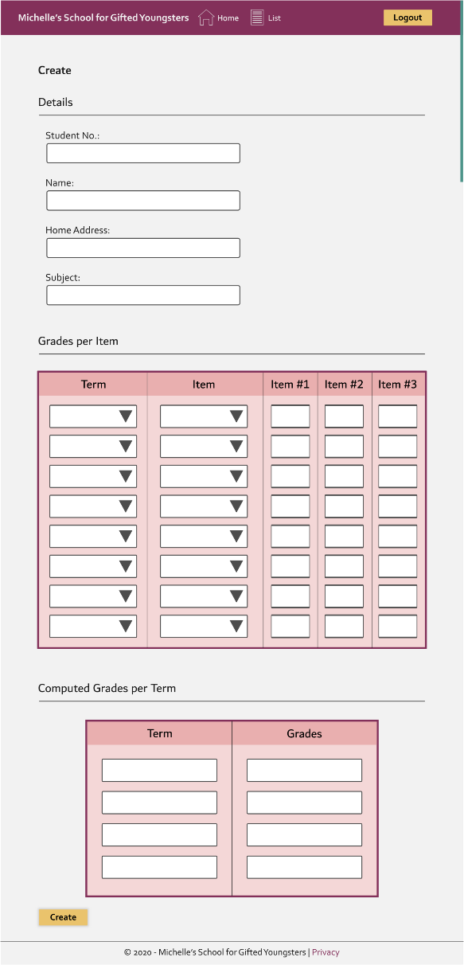

**Admin Edit Page (Dark & Light Mode)**

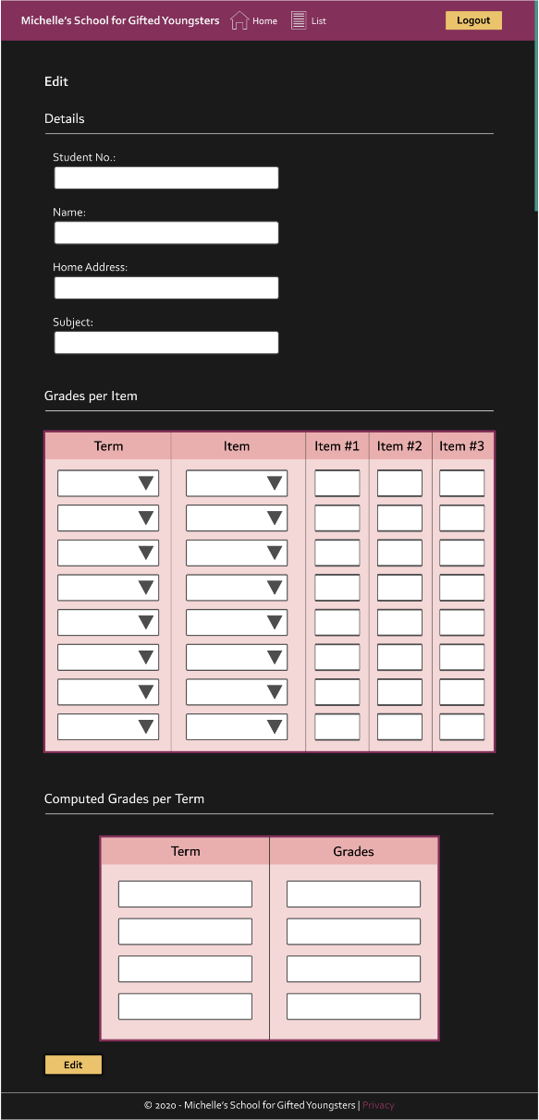

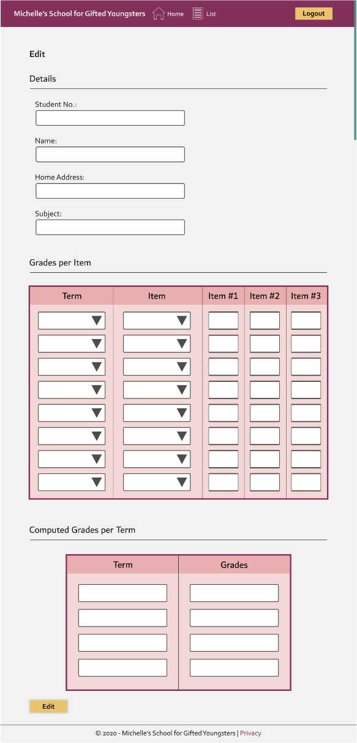

**Admin Details Page (Dark & Light Mode)**

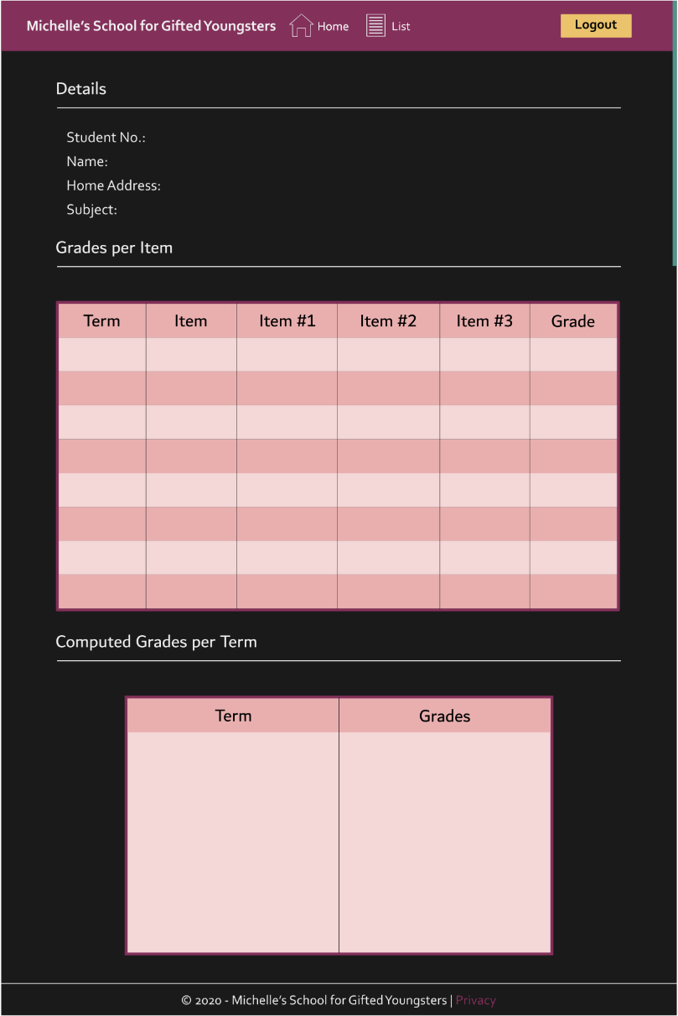

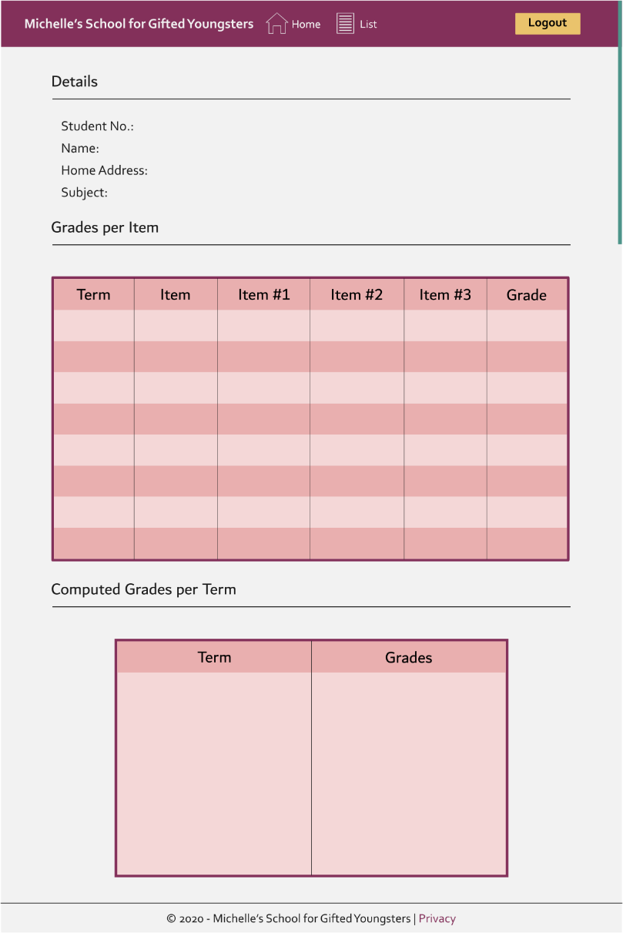

**In Progress Pre-Development/Planning Stage**

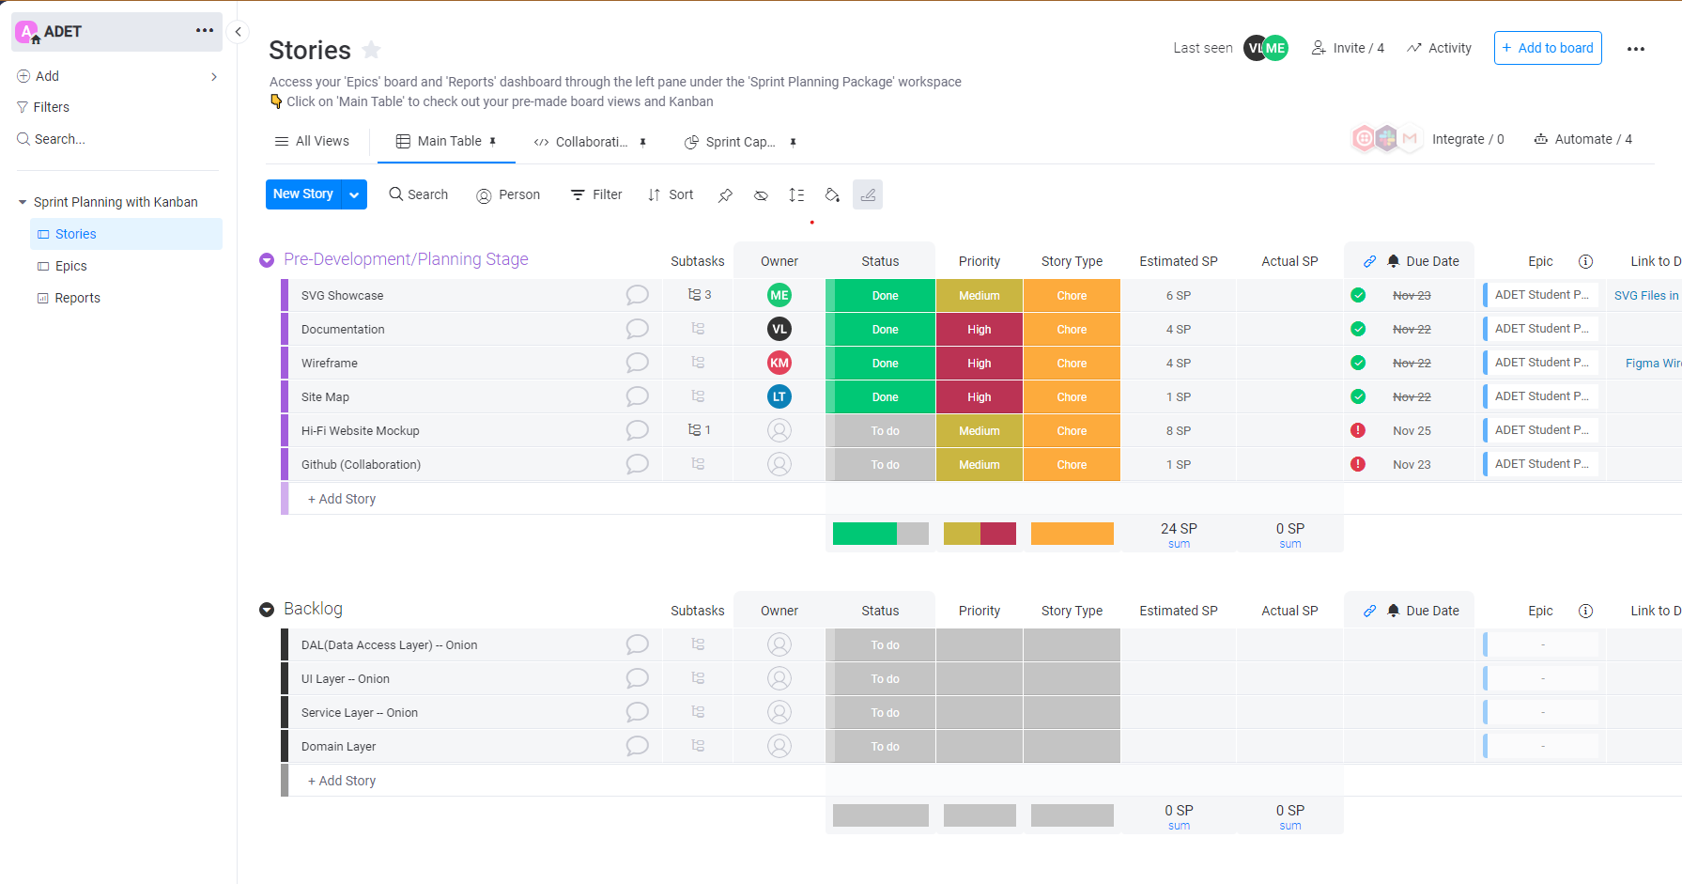

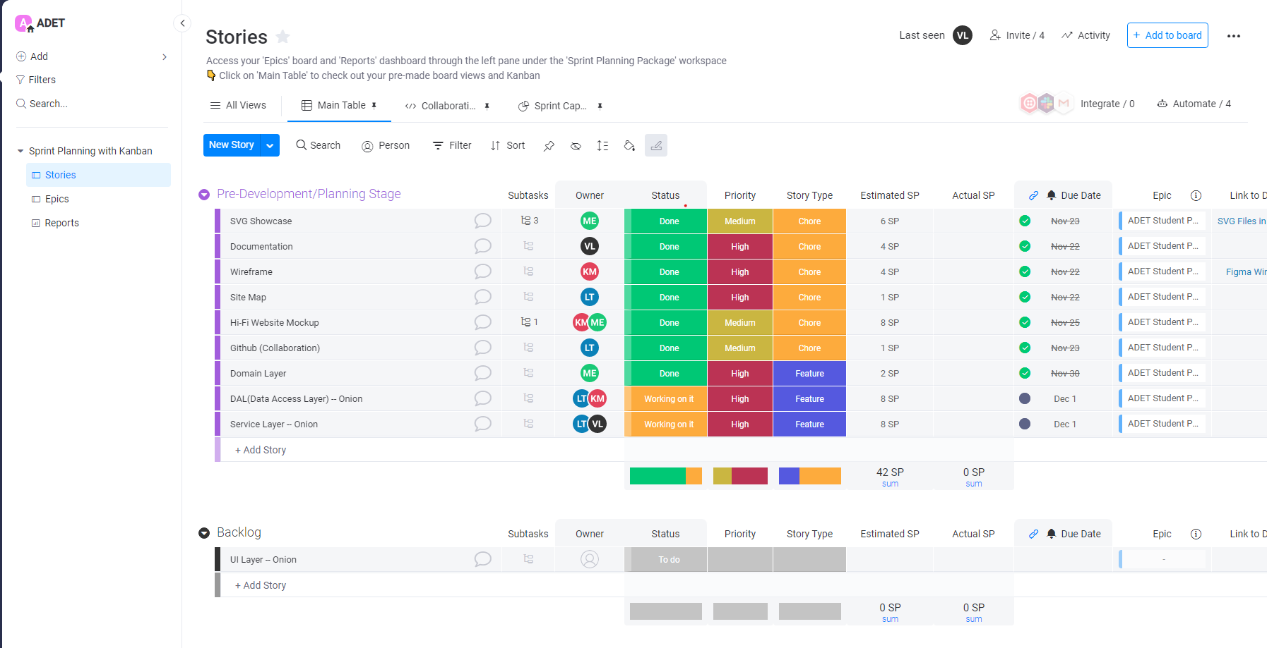

**CONVERSATION**

